AVR Flags
Version 0.1
David Lowther

Revision History
15 Jun 2026 | First Draft
16 Jun 2026 | Added sections 3.1.1, 3.1.2, and 3.1.3
17 Jun 2026 | Added sections 3.1.4 to 3.2.1.5
18 Jun 2026 | - Fixed copy / paste error in 3.1.4 that Earth reported in Discord this morning  - We agreed INC and DEC would be done by the ALU so removed this “Note: If INC is done by the register itself ...” from 2.8 for INC and from 2.9 for DEC.  - Added missing text for where Figure 8 is from in 2.9

Contents
1 Introduction 1
2 AVR Flags 1
2.1 Ref 1 Nomenclature: 2
2.2 Flags: AND Ra,Rb 2
2.3 Flags: OR Ra,Rb 2
2.4 Flags: NOT Ra, 3
2.5 Flags: ADD Ra,Rb 4
2.6 Flags: SUB Ra,Rb 5
2.7 Flags: XOR Ra,Rb 5
2.8 Flags: INC Ra 5
2.9 Flags: DEC Ra 6
2.10 Flags: CMP Ra,Rb 6
3 Examples and the Rationale for How the Flags are Set 7
3.1 Examples of How Flags are Set 7
3.1.1 Simple add of 2 small numbers 7
3.1.2 Add of 2 large numbers 8
3.1.3 Add of 2 very large numbers 9
3.1.4 Add of two small negative numbers 10
3.1.5 Add of two large negative numbers 10
3.1.6 Add of two overly large negative numbers 11
3.1.7 Add small negative number to smaller positive number 11
3.1.8 Add small negative number to same magnitude positive number 12
3.1.9 Add small negative number to larger positive number 12
3.1.10 Subtract small positive number from larger positive number 13
3.1.11 Subtract small positive number from smaller positive number 13
3.1.12 Subtract small positive number from an equal positive number 14
3.1.13 Subtract largest positive number from smallest negative number 14
3.1.14 Subtract large positive number from large negative number 14
3.2 Rationale for the Flag Setting Rules and Conditional Jumps 15
3.2.1 Broad Understanding of the Purpose of Each Flag 15
4 References 20

Figures
Figure 1: AVR Flags 1
Figure 2: Flags for AND Ra,Rb 2
Figure 3: Flags for NOT Ra 3
Figure 4: Flags for ADD Ra,Rb 4
Figure 5: Google Result for Order of Precedence 4
Figure 6: Flags for SUB Ra,Rb 5
Figure 7: Flags for INC Ra 5
Figure 8: Flags for DEC Ra 6
Figure 9: Adding two small numbers 7
Figure 10: Adding two large numbers 8
Figure 11: Adding two very large numbers 9
Figure 12: Adding two small negative numbers 10
Figure 13: Adding two large negative numbers 10
Figure 14: Adding two overly large negative numbers 11
Figure 15: Adding small negative number to smaller positive number 11
Figure 16: Adding small negative number to same value positive number 12
Figure 17: Subtracting small positive number from larger positive number 13
Figure 18: Subtracting small positive number from smaller positive number 13
Figure 19: Subtracting small positive number from equal positive number 14
Figure 20: Subtracting large positive number from large negative number 14

Introduction
The purpose of this document is:
- To document what flags the AVR has relating to logical and arithmetic operations
- To document how AVR handles ADD and SUB and what flags are affected
- To document how AVR handles arithmetic operations on signed and unsigned numbers
This will be done by studying Ref 1.

AVR Flags
Figure 1, from Ref 1 section 1, shows the AVR flags. I added the numbers.
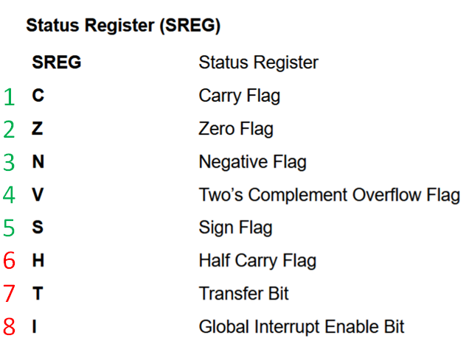
Figure 1: AVR Flags
We don’t need the flags with red numbers:
- Half Carry Flag: is used for BCD operations*
- Transfer Bit: Google “what is avr sreg transfer bit used for” if you want more information
- Global Interrupt Enable Bit:*
* We aren’t supporting interrupts or BCD operations (at least not for the current version of the design)
So that leaves 5 flags (C, Z, N, V and S). We should understand how AVR sets / clears them for each of the arithmetic / logical operations that we support, namely:
- AND Ra,Rb
- OR Ra,Rb
- NOT Ra,
- ADD Ra,Rb
- SUB Ra,Rb
- XOR Ra,Rb
- INC Ra
- DEC Ra
- CMP Ra,Rb

Ref 1 Nomenclature:
Ref 1 uses the following nomenclature:
- Rd (the input value, not the result) where we use Ra
- Rr where we use Rb
- R for the result (the value we normally, except for CMP, put in our Ra)
- ^ for logical AND
- v for logical OR
- for logical XOR
- R7 for our R15 (MSB) of result
- Result 0x00 for our result 0x0000
- Rd7 where we need to use Ra15
- Rr7 where we need to use Rb15
- R7 where we need to use R15

Flags: AND Ra,Rb
Figure 2 is from ref 1 section 6.4.2.
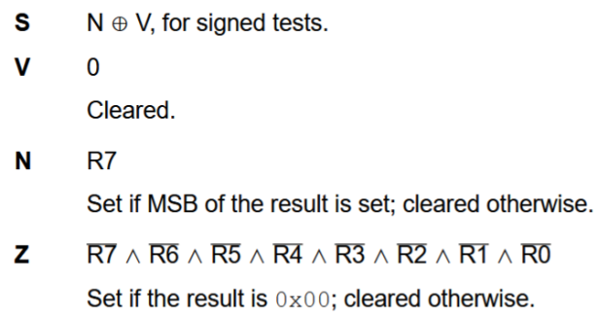
Figure 2: Flags for AND Ra,Rb
I think it’s self explanatory how our ALU should set the flags using the above information and the information in 2.1. Note that C, the carry flag, is not modified by this instruction.

Flags: OR Ra,Rb
Same as in 2.2 Flags: AND Ra,Rb see ref 1 section 6.82.2.

Flags: NOT Ra,
The corresponding AVR instruction is COM. In Ref 1 it says this instruction performs a 1’s complement, which (I checked with Google to be sure) is defined as “The 1's complement of a binary number is obtained by inverting all its bits: every 0 becomes a 1, and every 1 becomes a 0”
Figure 3 is from ref 1 section 6.44.2.
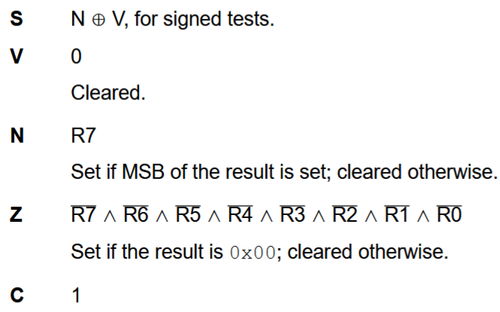
Figure 3: Flags for NOT Ra
I think it’s self explanatory how our ALU should set the flags using the above information and the information in 2.1. Note that C, the carry flag, is set by this instruction.

Flags: ADD Ra,Rb
Figure 4 is from ref 1 section 6.2.2.
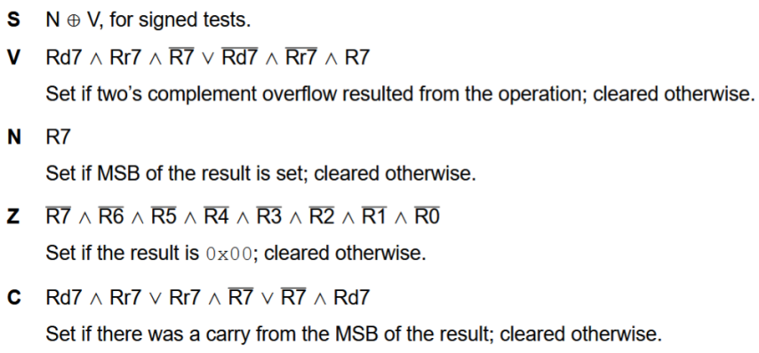
Figure 4: Flags for ADD Ra,Rb
I’m not sure about the order of precedence for the evaluation of the logical expressions for V and C. I asked Google AI and got the answer shown in Figure 5.
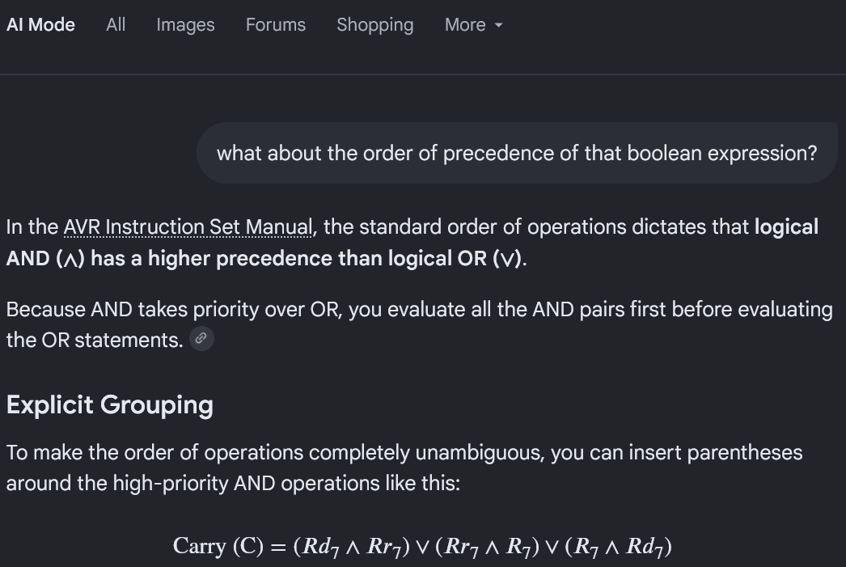
Figure 5: Google Result for Order of Precedence
In my translations below, I’ll use “!” to represent an inverted bit.
For V translates to
- V = (Ra15 AND Rb15 AND !R15) OR (!Ra15 AND !Rb15 AND R15)
For C translates to
- C= (Ra15 AND Rb15) OR (Rb15 AND !R15) OR (!R15 AND Ra15)
It’s worth looking at the full Google AI answers for e.g. C “what does "Rd7 ∧ Rr7 ∨ Rr7 ∧ R7 ∨ R7 ∧ Rd7" mean in AVR instruction set manual”. The results for C and V expressions explain the reasons why these Boolean expressions give us the needed flag result for signed and unsigned maths.

Flags: SUB Ra,Rb
Figure 6 is from ref 1 section 6.119.2.
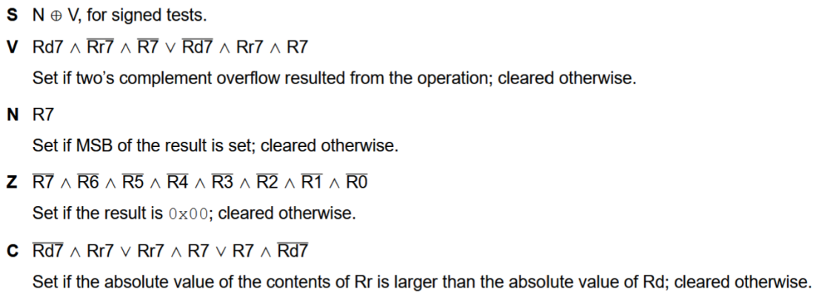
Figure 6: Flags for SUB Ra,Rb
See 2.5 for how to interpret the above logical expressions for V and C.
For V translates to
- V = (Ra15 AND !Rb15 AND !R15) OR (!Ra15 AND Rb15 AND R15)
For C translates to
- C= (!Ra15 AND Rb15) OR (Rb15 AND R15) OR (R15 AND !Ra15)

Flags: XOR Ra,Rb
Same as in 2.2 Flags: AND Ra,Rb see ref 1 section 6.54.2.

Flags: INC Ra
Note: If INC is done by the register itself, rather than via ALU, then ALU flags won’t change. The text in this section currently assumes INC will be done via ALU.
Figure 7 is from ref 1 section 6.61.2.
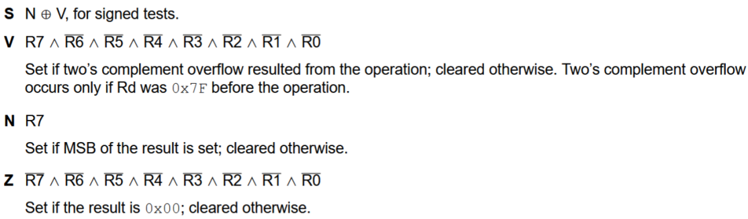
Figure 7: Flags for INC Ra
See 2.5 for how to interpret the above logical expressions for V but basically it’s quite simple in this case. V = 1 if result is 0x8000 else V = 0.
Note that C, the carry flag, is not modified by this instruction

Flags: DEC Ra
Figure 8 Is from ref 1 section 6.49.2.
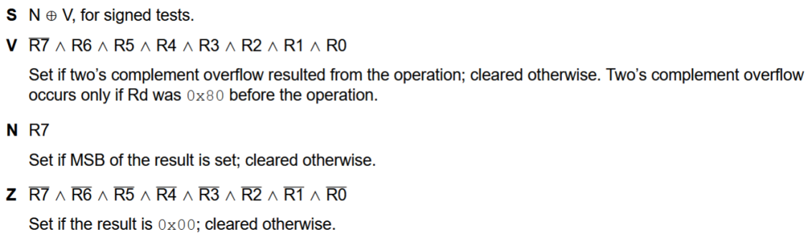
Figure 8: Flags for DEC Ra
See 2.5 for how to interpret the above logical expressions for V but basically it’s quite simple in this case. V = 1 if result is 0x7FFF else V = 0.
Note that C, the carry flag, is not modified by this instruction

Flags: CMP Ra,Rb
Same as in 2.6 Flags: SUB Ra,Rb see ref 1 section 6.45.2.

Examples and the Rationale for How the Flags are Set
Sections 2.* show what flags AVR uses and how each of our logical / arithmetic operations should set those 5 flags to either 1 or 0 for each of those operations.
Sections 3.1.* will show some examples of signed and unsigned arithmetic, using ADD Ra,Rb and Sub Ra,Rb.
Sections 3.2.* will explore and explain the rationale for why AVR sets flag bits the way it does, and how assembly code would use them for conditional jumps.

Examples of How Flags are Set

Simple add of 2 small numbers
This example shows two small numbers being added. It doesn’t matter whether they are considered to be signed or unsigned, because neither of the numbers to be added has bit15 set and the result doesn’t have bit 15 set.
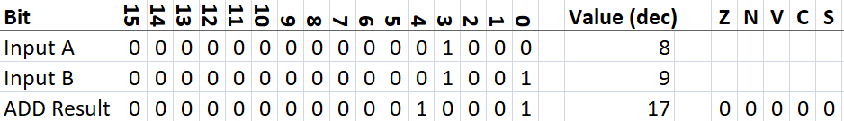
Figure 9: Adding two small numbers
- Z: Not set because result is not 0x0000
- N: Not set because bit 15 of the result is not set
- V: Not set because there was no 2’s complement overflow
- C: Not set because there was no carry out of bit 15
- S: Not set because neither N or V is set (S=V XOR N)

Add of 2 large numbers
This example shows two large numbers being added. Neither number has bit 15 set, so it doesn’t matter whether they are considered to be signed or unsigned.
The numbers are large enough to cause result bit 15 to be set, but not large enough to cause a carry out of bit 15.
- The result is correct if the numbers are considered to be unsigned.
- The result is wrong if the numbers are considered to be signed, because result bit15 is set, i.e. if we add two positive signed numbers, the result shouldn’t be a negative number.
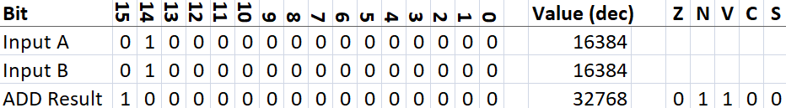
Figure 10: Adding two large numbers
- Z: Not set because result is not 0x0000
- N: Set because bit 15 of the result is set
- V: Set because there was a 2’s complement overflow.
  - This is an overflow condition if we consider the numbers to be signed because
    - Neither number had the sign bit set, but result does have the sign bit set.
    - Adding two positive numbers shouldn’t give a negative number as the result.
  - We should ignore this flag if we consider the numbers to be unsigned
- C: Not set because there was no carry out of bit 15
- S: Not set because both N and V are set (S=V XOR N)

Add of 2 very large numbers
This example shows two large numbers (either +32768 or -32768 [if we consider them to be signed]) being added, they both have bit 15 set. The ADD causes a carry out of bit 15.
- The result is wrong if we consider the numbers to be unsigned because 32768 + 32768 = 65536 not 0.
- The result is also wrong if we consider the numbers to be signed, because -32768 + (-32768) = -65536 not 0.
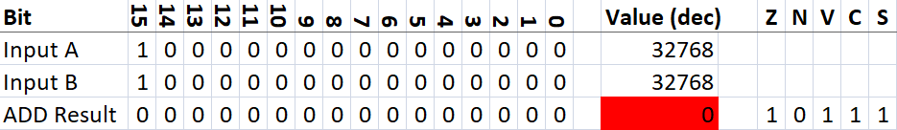
Figure 11: Adding two very large numbers
- Z: Set because result is 0x0000
- N: Not set because bit 15 of the result is not set
- V: Set because there was a 2’s complement overflow.
  - This is an overflow condition if we consider the numbers to be signed, because
    - Both numbers had the sign bit set, but the result does have the sign bit set.
    - We shouldn’t get a positive value by adding two negative numbers together
  - We should ignore this flag if we consider the numbers to be unsigned.
- C: Set because there was a carry out of bit 15
  - This is an overflow condition if we consider the numbers to be unsigned
  - <tbd> I’ve not considered if carry out of bit 15 is always an overflow for signed numbers
- S: Set because N isn’t set and V is set (S=V XOR N)

Add of two small negative numbers
This example shows adding -1 to -1. See footnote (spreadsheet regards bit 15 as -32768).
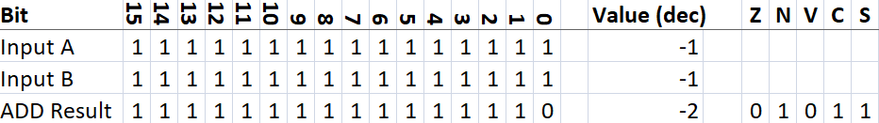
Figure 12: Adding two small negative numbers
- Z: Not set because result is not 0x0000
- N: Set because bit 15 of the result is set
- V: Not set because there was no 2’s complement overflow
- C: Set because there was a carry out of bit 15
  - Assembly code can ignore this, because adding two negative signed numbers will normally cause a carry out of bit 15
- S: Set because N is set and V isn’t set (S=V XOR N)

Add of two large negative numbers
This example shows adding -16384 to -16384. See footnote 1 (spreadsheet regards bit 15 as -32768). It produces the largest negative number (-32768) that can be represented in 16 bit 2’s complement.
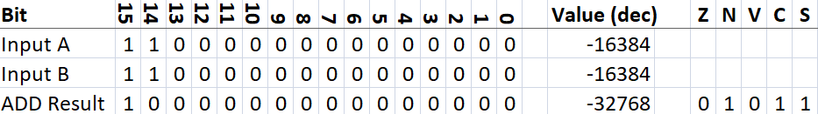
Figure 13: Adding two large negative numbers
- Z: Not set because result is not 0x0000
- N: Set because bit 15 of the result is set
- V: Not set because there was no 2’s complement overflow
- C: Set because there was a carry out of bit 15
  - Assembly code can ignore this, because adding two negative signed numbers will normally cause a carry out of bit 15
- S: Set because N is set and V isn’t set (S=V XOR N)

Add of two overly large negative numbers
This example shows adding -16384 to -16385. See footnote 1 (spreadsheet regards bit 15 as -32768). The correct answer would be -32769, but that’s larger than the largest negative number (-32768) that can be represented in 16 bit 2’s complement.
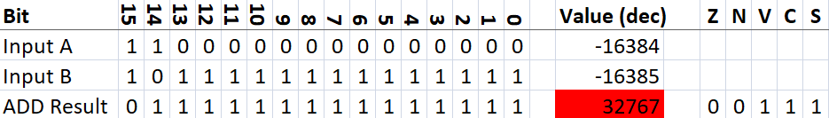
Figure 14: Adding two overly large negative numbers
- Z: Not set because result is not 0x0000
- N: Not set because bit 15 of the result is not set
- V: Set because there was a 2’s complement overflow
- C: Set because there was a carry out of bit 15
  - Assembly code can ignore this, because adding two negative signed numbers will normally cause a carry out of bit 15
- S: Set because N is set and V isn’t set (S=V XOR N)

Add small negative number to smaller positive number
This example shows adding -16 to 6. See footnote 1 (spreadsheet regards bit 15 as -32768).
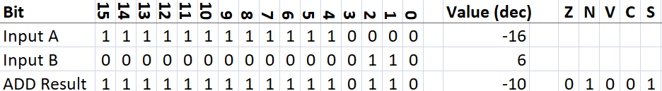
Figure 15: Adding small negative number to smaller positive number
- Z: Not set because result is not 0x0000
- N: Set because bit 15 of the result is set
- V: Not set because there was no 2’s complement overflow
- C: Not set because there was a carry out of bit 15
- S: Set because N is set and V isn’t set (S=V XOR N)

Add small negative number to same magnitude positive number
This example shows adding -6 to 6. See footnote 1 (spreadsheet regards bit 15 as -32768).
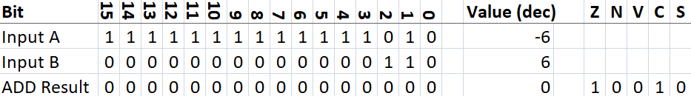
Figure 16: Adding small negative number to same value positive number
- Z: Set because result is 0x0000
- N: Not set because bit 15 of the result is not set
- V: Not set because there was no 2’s complement overflow
- C: Set because there was a carry out of bit 15 (0xFFFA + 0x6 = 0x1,0000)
  - Assembly code can ignore this, because there was no 2’s complement overflow.
- S: Not set because neither N or V are set (S=V XOR N)

Add small negative number to larger positive number
This example shows adding -6 to 16. See footnote 1 (spreadsheet regards bit 15 as -32768).
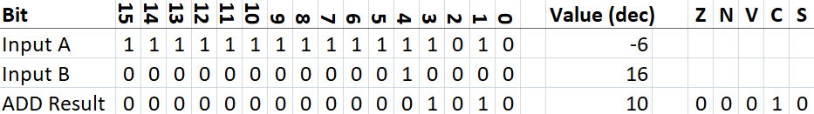
- Z: Not set because result is not 0x0000
- N: Not set because bit 15 of the result is not set
- V: Not set because there was no 2’s complement overflow
- C: Set because there was a carry out of bit 15 (0xFFFA + 0x10 = 0x1,000A)
  - Assembly code can ignore this, because there was no 2’s complement overflow.
- S: Not set because neither N or V are set (S=V XOR N)

Subtract small positive number from larger positive number
This example shows subtracting 3 from 4. It doesn’t matter if we regard these numbers, or the result, as signed or unsigned because none of them have bit 15 set.
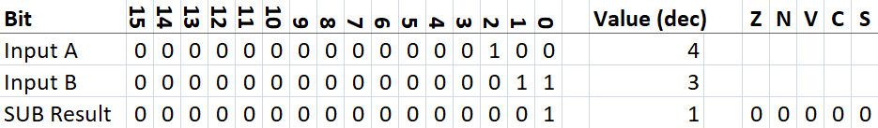
Figure 17: Subtracting small positive number from larger positive number
- Z: Not set because result is not 0x0000
- N: Not set because bit 15 of the result is not set
- V: Not set because there was no 2’s complement overflow
- C: Not set because there was no unsigned underflow
  - I’ll only explain this once in this doc, but it applies to all subtractions. I checked the meaning of the carry flag for (AVR) subtractions and found:
    - In AVR assembly, a carry flag (C) set after a SUB (Subtract) instruction means the operation required a borrow. This happens when the number you are subtracting is strictly larger than the number you are subtracting it from. The carry flag is essentially the hardware's way of telling you "there was an unsigned underflow"
- S: Not set because neither N or V are set (S=V XOR N)

Subtract small positive number from smaller positive number
This example shows subtracting 4 from 3. It doesn’t matter if we regard these number signed or unsigned because neither of them have bit 15 set.
It does matter whether we regard the result as signed or unsigned, because it causes an underflow if we regard the answer as unsigned, but the result is correct if we regard it as signed. See footnote 1 (spreadsheet regards bit 15 as -32768).
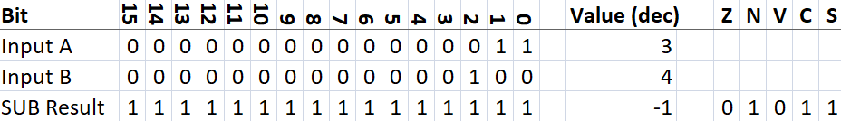
Figure 18: Subtracting small positive number from smaller positive number
- Z: Not set because result is not 0x0000
- N: Set because bit 15 of the result is set
- V: Not set because there was no 2’s complement overflow
- C: Set because the operation would cause an unsigned underflow
- S: Set because N is set and V isn’t set (S=V XOR N)

Subtract small positive number from an equal positive number
This example shows subtracting 4 from 4. It doesn’t matter if we regard these numbers, or the result, as signed or unsigned because none of them have bit 15 set.
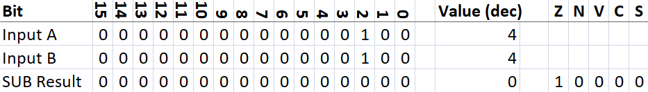
Figure 19: Subtracting small positive number from equal positive number
- Z: Set because result is 0x0000
- N: Not set because bit 15 of the result is not set
- V: Not set because there was no 2’s complement overflow
- C: Not set because there was no unsigned underflow
- S: Not set because neither N or V is set (S=V XOR N)

Subtract largest positive number from smallest negative number
This example shows subtracting 32767 from -1. See footnote 1 (spreadsheet regards bit 15 as -32768).
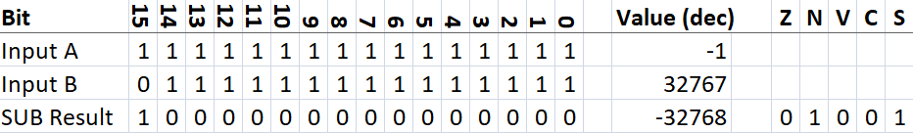
- Z: Not set because result is not 0x0000
- N: Set because bit 15 of the result is set
- V: Not set because there was no 2’s complement overflow
- C: Not set because there was no unsigned underflow
- S: Set because N is set and V isn’t set (S=V XOR N)

Subtract large positive number from large negative number
This example shows subtracting 16384 from -16385, the real result would be -32769, which is more than the 16 bit 2’s complement limit of -32768. See footnote 1 (spreadsheet regards bit 15 as -32768).
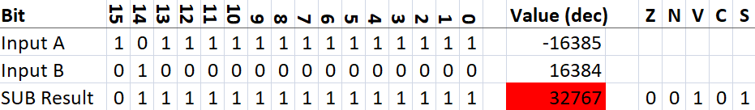
Figure 20: Subtracting large positive number from large negative number
- Z: Not set because result is not 0x0000
- N: Not set because bit 15 of the result is not set
- V: Set because there was a 2’s complement overflow
- C: Not set because there was no unsigned underflow
- S: Set because N isn’t set and V is set (S=V XOR N)

Rationale for the Flag Setting Rules and Conditional Jumps
Sections 3.2.* will refer to the examples in 3.1.* to help with the further explanations contained below.

Broad Understanding of the Purpose of Each Flag
Sections 3.2.1*, 1 per flag, will explain the purpose of each flag.
Assembly code examples will use J<flag letter> to jump if the flag is set, and use JN<flag letter> to jump if the flag is not set.
Whether or not we actually support these 10 conditional jump instructions is tbd, but I think we should. There is no reason to reserve opcode bits 7..0 for Ra,Rb as the jump instructions don’t use registers. We could have the flag pattern for the conditional jump in bits 3..0.
It’s sometimes annoyingly inconvenient in assembly language if both options aren’t available. (see second code block in 3.2.1.1 below)

Purpose of Z Flag
This simply means that the result of an ALU operation was zero.
If we wanted to write a loop that executes 4 times, in our assembly language, we’d write:
LIM R0,4
LOOP: ADD R1,R2 ; The code we want to execute 4 times
SUB R3,R4 ; The code we want to execute 4 times
DEC R0
JNZ LOOP ; If R0 wasn’t decremented to 0, jump back up to LOOP
; Next part of the code would go here

If we only had JZ opcode, and didn’t have JNZ opcode, the above would have to be written like this:
LIM R0,4
LOOP: ADD R1,R2 ; The code we want to execute 4 times
SUB R3,R4 ; The code we want to execute 4 times
DEC R0
JZ SKIP ; If R0 was decremented to 0, jump over the next instruction
JMP LOOP
SKIP: ; Next part of the code would go here

The first block of code is cleaner. Just “JNZ LOOP” cf. the yellow highlighted code above. Maybe not that much cleaner for just one simple conditional branch, but if there’s some real code with a lot of conditional branches, being able to use the most appropriate J<flag> or JN <flag> makes the code easier to write and easier to understand.

Purpose of N Flag
This simply means that the result of an ALU operation had bit 15 set.
I had to check the use of this flag with Google AI by asking it “when does AVR assembly code need to check the N flag?” My summary of the rather long answer allowing for our 16 bits cf. AVR’s 8 bit is:
- When dealing with unsigned numbers (0 to 65535):
  - The N flag does not indicate standard negative values. Instead, you check it to see if a value is greater than or equal to 32768.
- When dealing with signed numbers (-32768 to 32767):
  - You should check the N flag for signed operations only if you are certain that the calculation did not cause an arithmetic overflow.
  - For reliable signed operations, you rarely want to check the N flag in isolation. Instead, AVR provides the S (Sign) flag
If we wanted to write a loop, using unsigned maths, that keeps adding 0x1000 to R5 until R5 is >= 32768, in our assembly language we’d write:
LIM R0,0x1000
LIM R5,0
LOOP: ADD R1,R2 ; The code we want to execute while R5 < 32768
SUB R3,R4 ; The code we want to execute while R5 < 32768
ADD R5,R0
JNN LOOP ; If R5 isn’t >= 32768, jump back up to LOOP

That’s a fairly pointless example as it does nothing particularly useful that we couldn’t do by running the loop 8 times, but it does show how we’d use a conditional jump based on the N flag safely for unsigned maths.

Purpose of V Flag
This is for use when we are doing 2’s complement maths. It gets set when:
- We add two positive numbers and the result has bit 15 set. That indicates the result has become negative due to 2’s complement overflow (example in 3.1.2).
- We do add two negative numbers and the result has bit 15 clear. That indicates the result has become positive due to 2’s complement underflow (example in 3.1.6).
- We subtract a positive number from a negative number and the result would exceed the -32768 limit for 16 bit 2’s complement (example in 3.1.14)
If we wanted to some code, using signed maths, that is called from other code and passed two signed numbers in R0 and R1, and our code has to:
- Calculate the signed sum of those two numbers and put the sum in R2
- Calculate the signed difference of those two numbers and put the difference in R3
- Set R4 to 0 if no error occurred, else set R4 to 1
We would write the following code:
LIM R4,0 ; Assume no error to start with
CPY R2,R0
ADD R2,R1 ; R2 = Signed sum of R0 and R1
JV ERROR ; Don’t bother calculating difference if sum caused overflow
CPY R3,R0
SUB R3,R1 ; R3 = Signed difference (R0-R1)
JV ERROR
RETURN ; We should just use “RET” for the mnemonic
ERROR: LIM R4,1 ; Indicate that there was an error
RETURN

Purpose of C Flag
I asked Google AI “What mathematical operations cause the C flag to be set?”. My summary of the rather long answer allowing for our 16 bits cf. AVR’s 8 bit is:
- During addition, the C flag acts as the 17th bit of the result. It is set to 1 if the sum of the two numbers exceeds the maximum value of an 16 bit unsigned value (65535 or 0xFFFF)
- During subtraction, the C flag acts as a borrow flag. It is set to 1 if the number being subtracted is strictly greater than the number it is being subtracted from
If we wanted to implement a signed 32 bit maths add function we could pass the two numbers to our function like this:
- Signed number 1: bits 15 to 0 in R0, bits 31 to 16 in R1
- Signed number 2: bits 15 to 0 in R2, bits 31 to 16 in R3
- Signed number result: bits 15 to 0 in R4, bits 31 to 16 in R5
Bits 15 to 0 of each number will be unsigned, because the sign bit is in bit 31.
I’ll just show the first part of the function that adds the least significant 16 bits of the two numbers together:
LIM R7,0 ; Assume no carry from adding the two least significant parts
CPY R4,R0
ADD R4,R2 ; R4 = sum of bits 15 to 0 of the two 32 bit numbers
JNC DOMSW ; Skip setting R7 to 1
LIM R7,1 ; Remember there was a carry from adding bits 15 to 0 of the two numbers
DOMSW: ; Code to DO Most Significant Word sum goes here
; Sum R1,R3 and R7, possibly including an error flag in R6
RETURN

Purpose of S Flag
In 3.2.1.2 I quoted Google AI “For reliable signed operations, you rarely want to check the N flag in isolation. Instead, AVR provides the S (Sign) flag”.
To elaborate a little here, I asked Google AI “What is the purpose of the AVR S flag?” and, summarising, it said “Its sole purpose is to tell you if the true mathematical result of a signed operation is negative, even if an overflow occurred”
So if we wanted to know whether the actual result (not necessarily the correct result), of subtracting the number in R1 from the number in R0, is negative or positive, we could write some code like this:
SUB R0,R1
JNS POS
; code for handling whatever we want to do for negative numbers would go here
JMP COM ; Jump to the next common part of the code after handling negative result
POS: ; code for handling whatever we want to do for positive numbers would go here
COM: ; After handling special cases for negative and positive, code continues here

Our assembler (not the opcodes, but the program that turns assembly code into machine code) could have aliases for some of the conditional jumps, e.g:
- JNS (jump if not negative) could have the alias JGE (jump if greater than or equal to zero)
- JS (jump if negative) could have the alias JL (jump if less than zero)

References
- AVR Instruction Set Manual

The spreadsheet was changed so make the value of bit 15 = -32768 rather than +32768. I.E. it’s a human interpretation of whether the number is 2’s complement or unsigned.
Normal assembler line format is: optional label, opcode, optional comment starting with semi-colon.

